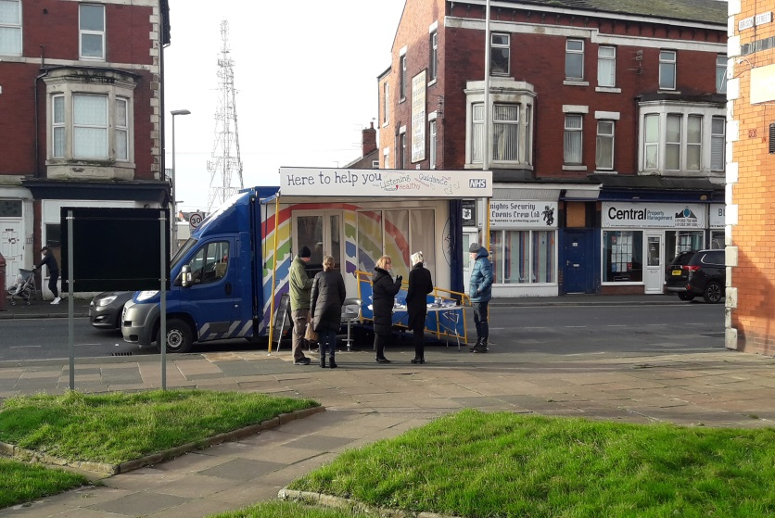

Come and meet HARRI near you!
HARRI is our health and wellbeing engagement vehicle, with it we are able to travel around Lancashire to talk with the local communities and individuals.
On board:
- We engage with you; to share our ideas and plans for the future and to gain insight into what your need are.
- We offer simple signposting, advice and guidance to offer the right help at the right time in the right place for you.
On board there will be a mixed group from within the NHS and beyond, which will enable us to offer you a wide range of information on many of the issues you may be facing, such as debt, quit smoking, diabetic DESMOND, Steady On, My Place, Lancashire Victim support and much more. The vehicle includes a private consulting area with disabled access.
People can visit HARRI at various locations and events throughout the year in Lancashire. For HARRI’s schedule, see the reverse of this leaflet or Lancashire Care Face book and twitter accounts for the latest updates.
HARRI is one of the many ways Lancashire Care NHS Foundation is using to reach out to communities to promote positive aspects of mental health and wellbeing.
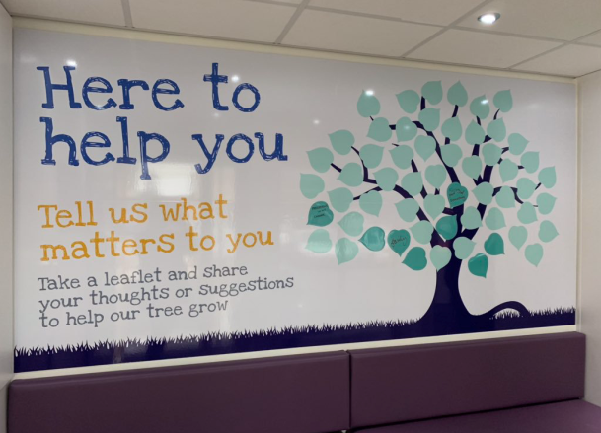

We hope to see you with HARRI soon.

Dates to pop on HARRI
HARRI is also available to attend health events and campaigns. It is the perfect vehicle to promote local services to a wide audience in just a few hours, allowing services to highlight their initiatives, raise awareness and discuss concerns. If you would like to hire HARRI for your next event, please get in touch for availability.
Venue/Event | Date | Times
Tesco Accrington  BB5 1LN | Thurs 2nd April 2020 | 10:00 - 3:00
Health Mela UCLAN , Greenbank Building, Victoria Street, Preston, PR1 2HE | Sat 4th April 2020 | 10:00 – 3:30
Chorley Market off Cleveland St Chorley PR71BH | Tues 7th April 2020 | 10.00 – 3:00
Flag market Cheapside, Preston PR1 2AP | Thurs 16th April 2020 | 10:00 – 3:00
Blackburn job centre health and wellbeing event, Penny St, Blackburn BB1 6HA | Tues 21st April 2020 | 10:00 – 3:00
Colne ASDA Swinden Retail Park, Unit 1, Corporation St, Colne BB8 8LU | Thurs 23rd April 2020 | 10:00 - 3:00
Recovery college partnership day The Harris Museum Preston PR1 2AP | Mon 27th April 2020 | 9:30 - 4:00
Recovery College partnership day The Pulse, Concourse Shopping centre, Skelmersdale, WN56LN | Tues 28th April 2020 | 9:30 - 4:00
Recovery college partnership day, Claremount community centre, Blackpool, FY1 2QJ | Fri 1st May 2020 | 9:30 – 12:30
Morrison Amounderness Way, Thornton-Cleveleys FY5 3TS | Tues 5th May 2020 | 10:00 - 3:00
Revoelution, Ibbison Court, Blackpool FY14AU | Thurs 7th May 2020 | 10:00 - 3:00
Leyland Market Northcote St, Leyland PR25 2AA | Tues 12th May 2020 | 10:00 – 3:00
Buzzing Bee family fun day Ightenhill park Burnley BB12 8AD | Sat 16th May 2020 | 10:30 – 3:30
Community health day, Little Marsden Parish church Nelson BB90DZ | Thurs 28th May 2020 | 10:00 – 3:00
 Call us on 01772 695 365 to speak to one of our friendly support team
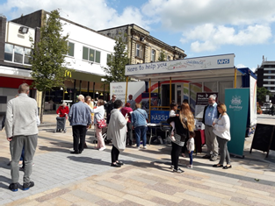
 Email us at recovery.college@lancashirecare.nhs.uk
@LancashireCare
@LancashireCare

