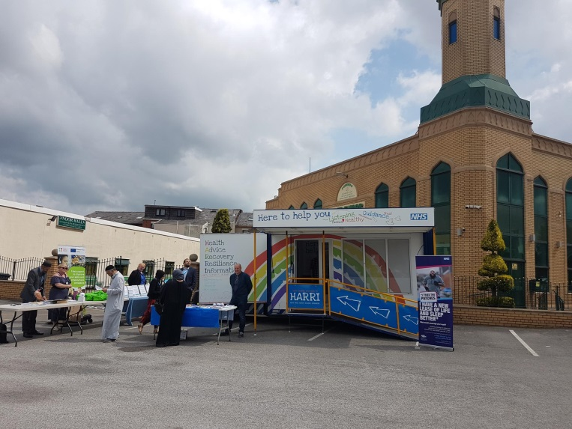

Come and meet HARRI near you!
HARRI is our health and wellbeing engagement vehicle, with it we are able to travel around Lancashire to talk with the local communities and individuals.
On board:
- We engage with you; to share our ideas and plans for the future and to gain insight into what your need are.
- We offer simple signposting, advice and guidance to offer the right help at the right time in the right place for you.
On board there will be a mixed group from within the NHS and beyond, which will enable us to offer you a wide range of information on many of the issues you may be facing, such as debt, quit smoking, diabetic DESMOND, Steady On, My Place, Lancashire Victim support and much more. The vehicle includes a private consulting area with disabled access.
People can visit HARRI at various locations and events throughout the year in Lancashire. For HARRI’s schedule, see the reverse of this leaflet or Lancashire Care Face book and twitter accounts for the latest updates.
HARRI is one of the many ways Lancashire Care NHS Foundation is using to reach out to communities to promote positive aspects of mental health and wellbeing.
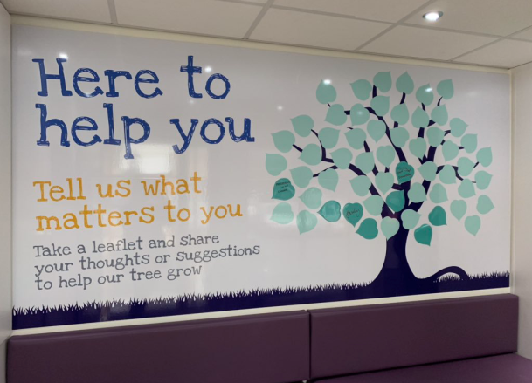

We hope to see you with HARRI soon.

Book HARRI
HARRI is also available to attend health events and campaigns. It is the perfect vehicle to promote local services to a wide audience in just a few hours, allowing services to highlight their initiatives, raise awareness and discuss concerns. If you would like to hire HARRI for your next event, please get in touch for availability.
Venue/Event | Date | Times
Flag Market , Preston, PR1 2AP | Thurs 5th March 2020 | 10.00 – 3:00
Burnley town centre, James Street TBC, non-smoking day | Weds 11th March 2020 | 10:00 – 3:00
Blackburn college Disability Information Day Feilden St, Blackburn BB2 1LH | Thurs 19th March 2020 | 10:00 - 3:00
Blackburn Mosque, Plane Tree RD Blackburn | Sun 22nd March 2020 | 10:30 – 3:00
Tesco Buckshaw Village Chorley PR7 7EL | Tues 24th March 2020 | 10:30 - 3:00
Tesco Haslingden BB4 6LY | Thurs 26th March 2020 | 10:00 - 3:00
Tesco Liverpool Road North Burscough Bridge, Ormskirk L40 0SA | Tues 31st March 2020 | 10:00 – 3:00
Tesco Accrington  BB5 1LN | Thurs 2nd April 2020 | 10:00 - 3:00
Health Mela UCLAN , Greenbank Building, Victoria Street, Preston, PR1 2HE | Sat 4th April 2020 | 10:00 - 3:00

 Call us on 01772 695 365 to speak to one of our friendly support team
 Email us at recovery.college@lancashirecare.nhs.uk
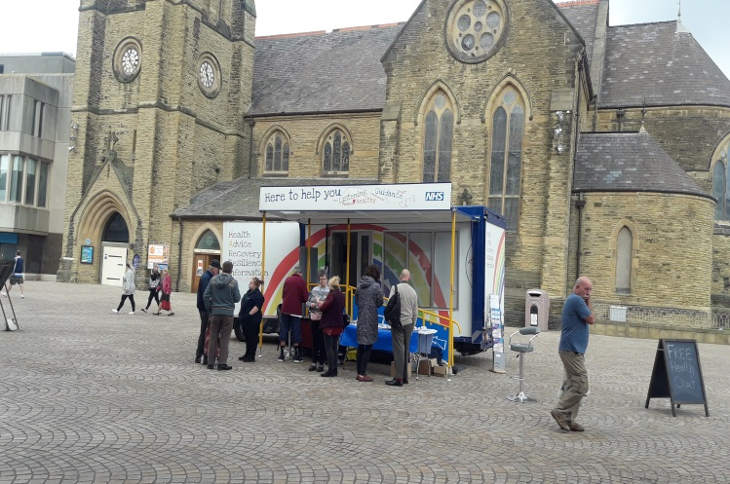
@LancashireCare
@LancashireCare

